School of Computer Science and Artificial Intelligence

Lab Assignment # 3.1

Name of Student : GINNE SAI TEJA
Enrollment No. : 2303A51529
Batch No. : 22

Question 1: Zero-Shot Prompting (Palindrome Number Program)
Write a zero-shot prompt (without providing any examples) to generate
a Python function that checks whether a given number is a palindrome.
Task:
• Record the AI-generated code.
• Test the code with multiple inputs.
• Identify any logical errors or missing edge-case handling.

Code:-
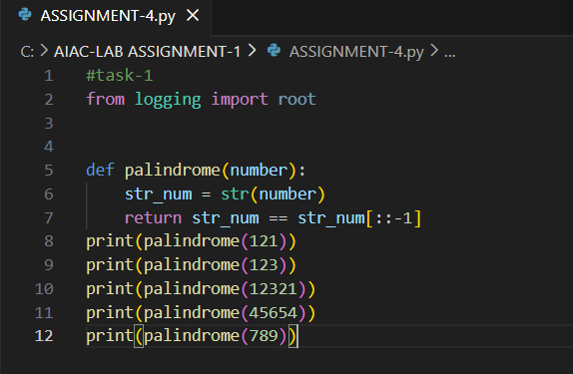

Output:-

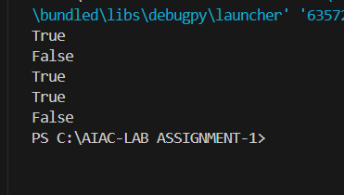
Question 2: One-Shot Prompting (Factorial Calculation)
Write a one-shot prompt by providing one input-output example and
ask the AI to generate a Python function to compute the factorial of a
given number.
Example:
Input: 5 → Output: 120
Task:
• Compare the generated code with a zero-shot solution.
• Examine improvements in clarity and correctness.

Prompt:-
Write a Python function factorial(n) that returns the factorial of a non-negative integer n.

Code:-
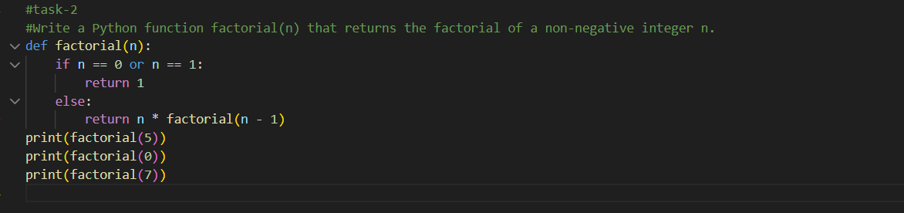

Output:-
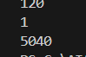

Question 3: Few-Shot Prompting (Armstrong Number Check)
Write a few-shot prompt by providing multiple input-output examples
to guide the AI in generating a Python function to check whether a
given number is an Armstrong number.
Examples:
• Input: 153 → Output: Armstrong Number
• Input: 370 → Output: Armstrong Number
• Input: 123 → Output: Not an Armstrong Number
Task:
• Analyze how multiple examples influence code structure and
accuracy.
• Test the function with boundary values and invalid inputs.
(Optional Extension)

Prompt:-
Write a Python function is_armstrong(n) that returns True if n is an Armstrong number and False otherwise.

Code:-
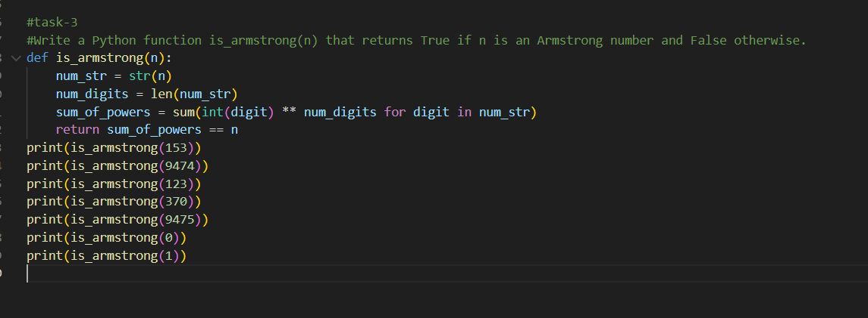

Output:-
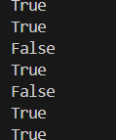

Question 4: Context-Managed Prompting (Optimized Number
Classification)
Design a context-managed prompt with clear instructions and
constraints to generate an optimized Python program that classifies a
number as prime, composite, or neither.
Task:
• Ensure proper input validation.
• Optimize the logic for efficiency.
• Compare the output with earlier prompting strategies.

Prompt:-
Write a Python program using a context manager that classifies a number as prime, composite, or neither.
Code:-
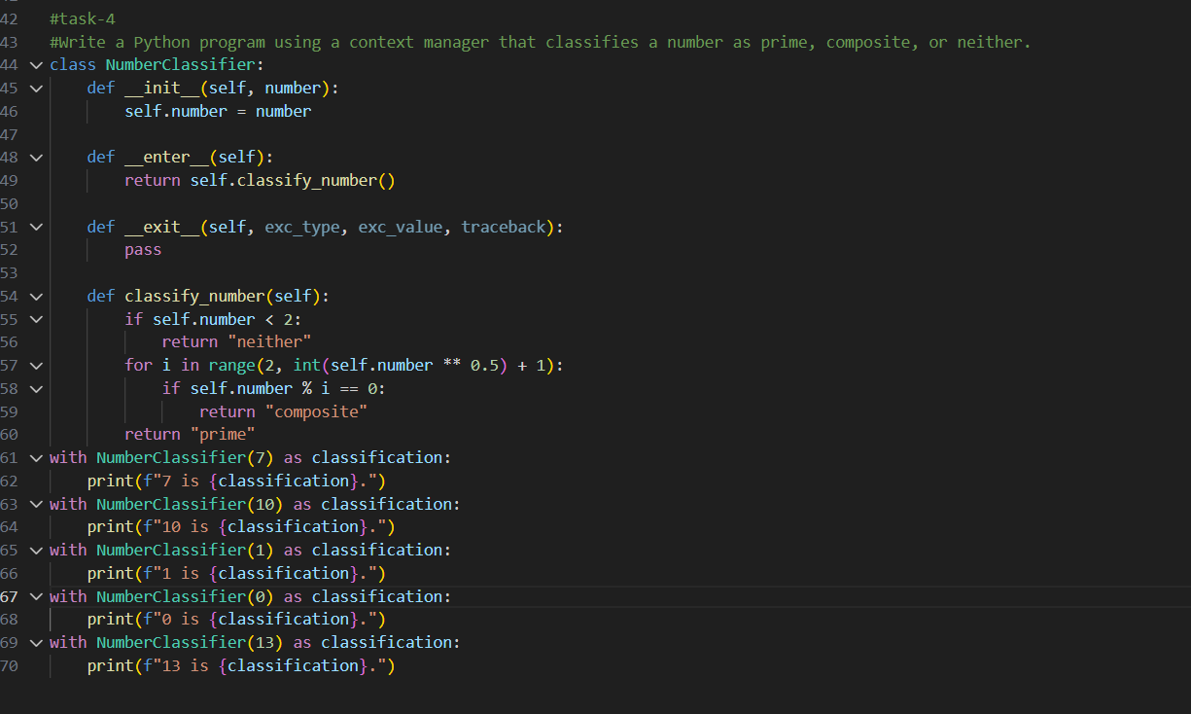

Output:-
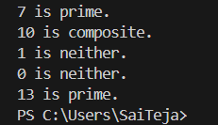

Question 5: Zero-Shot Prompting (Perfect Number Check)
Write a zero-shot prompt (without providing any examples) to
generate a Python function that checks whether a given number is a
perfect number.
Task:
• Record the AI-generated code.
• Test the program with multiple inputs.
• Identify any missing conditions or inefficiencies in the logic.

Code:-
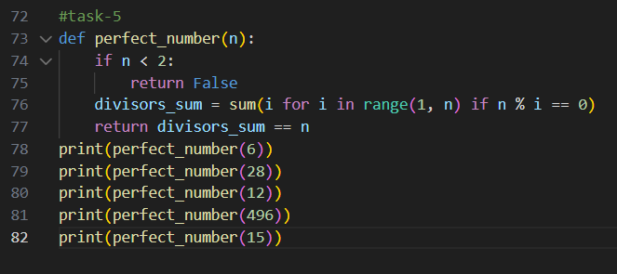

Output:-
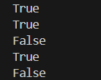

Question 6: Few-Shot Prompting (Even or Odd Classification with
Validation)
Write a few-shot prompt by providing multiple input-output
examples to guide the AI in generating a Python program that
determines whether a given number is even or odd, including proper
input validation.
Examples:
• Input: 8 → Output: Even
• Input: 15 → Output: Odd
• Input: 0 → Output: Even
Task:
• Analyze how examples improve input handling and output
clarity.
• Test the program with negative numbers and non-integer inputs.

Prompt:-
Write a Python function check_even_odd(n) that prints "Even" if n is even and "Odd" if n is odd.

Code:-
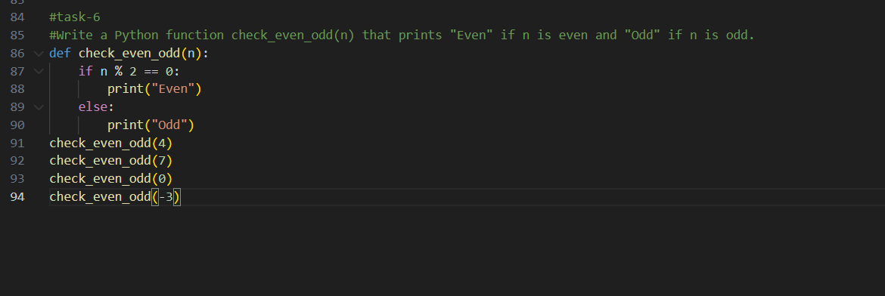

Output:-
